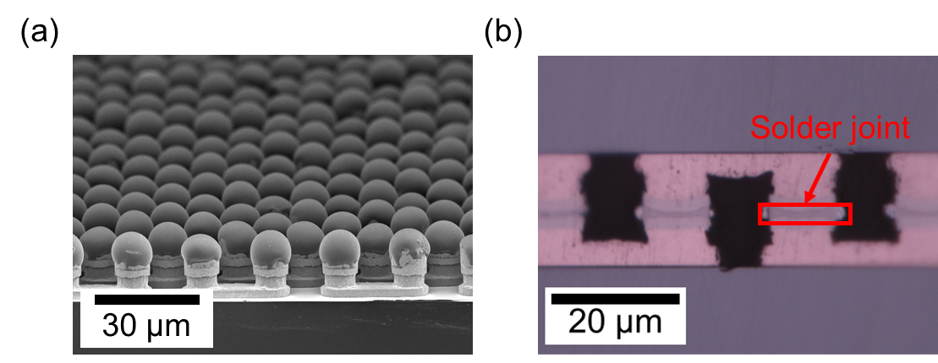

**Laser-Assisted Bonding with Compression**: To make high-bandwidth memory (HBM), memory dies with through-silicon vias are vertically stacked in 2.5 D or 3D packages, and physically/electrically interconnected by solder joints. But with increasing I/O density these joints are getting much smaller, and conventional soldering technology can no longer guarantee reliable interconnections because of warpage, fume generation, residual flux, and incomplete underfill coverage. Laser-assisted bonding (LAB) has attracted attention for fine-pitch interconnections because it minimizes thermally induced deformation of chips and substrates, and laser-assisted bonding with compression (LABC) improves alignment precision by applying constant pressure on the chips during bonding. At ECTC last year, ETRI reported a chip-on wafer technology using LABC with a laser non-conductive film (NCF). This year, an ETRI-led team will report on a localized formation of laser NCF on the surface of 10 µm diameter solder bumps and its application on 20 µm pitch interconnection. They carefully dipped the micro-bumps in the laser NCF to selectively coat only the surface of the SnAg solders. Then, the die with the laser NCF-coated micro-bumps was bonded to the substrate using LABC. Fine-pitch interconnections were achieved with no residue and fume generation.

**In the images above**:

1. is an electron microscope image of the 10 µm diameter solder bumps that were selectively coated by the laser NCF
2. is an optical microscopic image of the interface between the dipped top chip and the substrate, after LABC and bonding adhesive cure

**(Paper #31.5, “*Localized Formation of Laser Non-Conductive Film (NCF) on 10 µm Diameter Bumps, Applied to 20 µm Pitch Chiplet Chip-on-Wafer (CoW) Bonding*,” J. Shin et al, ETRI/Hanbat National Univ.)**